Indiana University O’Neill School of Public and Environmental Affairs
Arthur Lin Ku
Ph.D. in Public Affairs

EDUCATION:
B.A. Public Finance, National Cheng-Chi University, Taiwan, ROC
MSc. Economics, University of East Anglia, UK
M.A. Applied Statistics, Indiana University, US
Ph.D. Public Affairs, Indiana University, US

MAJOR FIELDS:
Energy Policy
Policy Analysis

FACULTY ADVISOR:
Sanya Carley

HOMETOWN:
Taipei, Taiwan(R.O.C)

HOBBIES:
Gym
FAVORITE HANGOUT:
Gym again
Trails

FAVORITE RESTAURANT:
It depends

PHONE:
530.574.9059

EMAIL:
alku@umd.edu

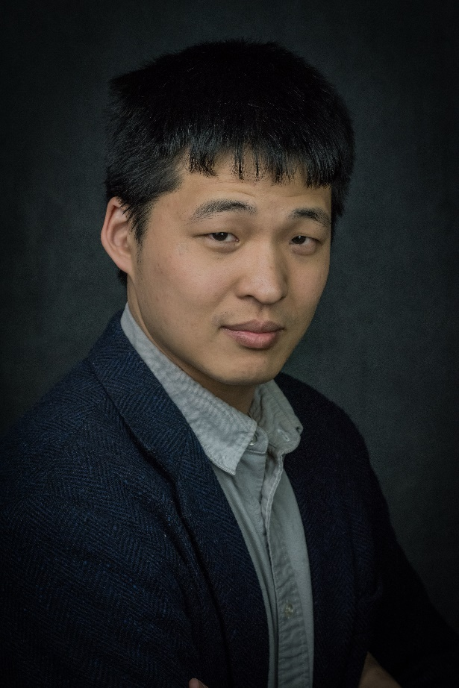

RESEARCH INTERESTS:

I recently receive my Ph.D. in Public Affairs and am now a postdoc at the University of Maryland. I am primarily focused on energy policies, energy justice, and China studies. My dissertation includes three essays on energy policy. I have work examining the equity of California EV rebates, a model exploration to the energy justice issue, and an evaluation on how China’s vehicle ownership restriction policy. I also have projects in various stages of the neighboring effects in China’s emission policy, and how COVID-19 affects energy inequality.

